Project Deliverable 2 Proposal

Andrew Witherite, Waylon Wu

IST261

1. Describe in detail all new and changed functionality your team intends to implement for project deliverable 2.

We will include a user interface that is not based from the output window, and we will instead create a UI for the user based from Swing. We will also add the functionality to create a new user account if the user does not already have an account.

1. Describe how you will implement this functionality. This can be done through design documents (such as those submitted in preparation for project deliverable 1), or through detailed descriptions of changes to or new classes, methods, and data. Be especially careful to document information flow between MVC components and all changes required in all of these components.

To implement the GUI functionality for this project, we will be working mainly in the ‘View’ class. We will have to create the GUI there, and have that GUI launch on project startup. To ensure that we follow MVC, we will have the controller tell the viewer to launch the GUI on startup. The creation of the GUI should be straight forward, as its functionality should be extremely similar to the current iteration of our project. All we should have to do is replace all of the input and output code we had printing to the console, and instead replace them with the GUI. To add the functionality of creating an account, we will have to add an additional button to the GUI. This can be simply done by adding it in the view. When the user clicks this button in the program, we will need to add code to support this function. We will be adding this to the model class. When the user clicks the ‘Create Account’ button, the view will send this to the model, which adds the inputted username and password to the list of users. Once the new user is added to the list, that user should behave like one of our default users, as it should now be a fully implemented account that has the ability to log in with our app.

1. Provide descriptions (or drawings of) any new user interface elements.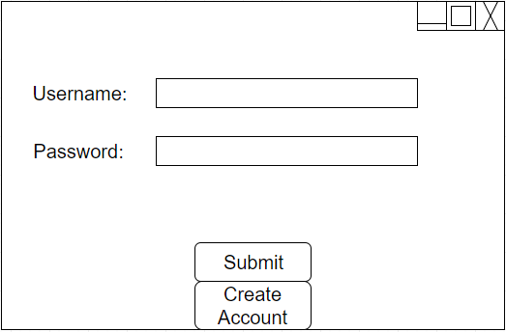

The new user interface that we will be creating will be the main screen the user sees when interacting with the app. It will be the login screen that displays all the required information for successful login. Currently, we have the information being displayed from the console, but with this deliverable, we plan to create a GUI for the user. This GUI will contain 2 text boxes with labels associated with them in the top-middle of the screen. These will prompt the user for input of a username and password. At the bottom-middle of the screen, the user will be able to hit a ‘Login’ button after they entered a username and password. This button has the same logical function as hitting enter in the console for our current project. When the user hits enter currently, it sends the entered information to the model for processing. The same logic will occur when the user hits the ‘Login’ button. Lastly, we will create a button ‘Create Account.’ This button, when clicked, will prompt the user to create a Username and Password. This will create an account for the user, which they can then use to login to the application with. This button will be located beneath the ‘Login’ button.

1. Describe how you will test this functionality.

To test the functionality for the new additions to the project, we will first test to ensure that the logic behind logging in with the default users still works properly. We will test the two users we currently have, and make sure that each of them can successfully login using the new GUI. Next, we have to test the functionality of our new component for this deliverable, creating a new user. To test this, we will be creating a test method which prints the users out that we currently have. For testing, this will show us that when the user creates a new account, that it is actually being added to the list. After we have ensured that this is working properly, we will delete this method, as it is not needed for the running version of the app. After we ensure that the ‘Create Account’ button works in creating an account and adding it to the list, we will test the new account. To do this, we simply attempt to login with the newly created user. If it allows us to log in with this user, then we know the program is working properly.

1. Describe the responsibilities of project team members in implementing this new functionality.

Waylon will be responsible for creating the UI for this assignment. Andrew will be responsible for the creation of new users for this assignment. We will both work together to ensure that the project follows basic MVC format. We will both also be involved in the testing of the elements we added for this assignment. We must both also work closely to ensure that the overlap between creating a new account and using the GUI goes smoothly. We will stay organized by making sure to run ideas past one another for any problems that arise. We will also be using the development tool ‘Trello’ to stay organized and to show our current progress on the project.